### Eastern Norwich

Indoor climbing wall, canoeing, various crafts (all teddy bear themed), a scavenger hunt and various game, along with a campfire before bed.

Then onto district cub construction camp, again at Eaton Vale, and they undertook archery, air rifles, climbing challenge, kayaking and the craft zone, where we had Lego, making the Da Vinci bridge and other crafts. They then had a campfire and various games brought along by the packs.

A massive thank you to all the leaders, young people and the parents for allowing us to put on these events, without your support the district programme couldn’t happen.

Over the last few months, the team have organised St George’s Day, which was rather soggy and cold, but that didn’t stop the young people from having a great time, The team would like to Thank the Norwich School and 8th Norwich Sea Scouts, for the use of their field and facilities, activities included canoes, stand up paddleboard, archery, air rifles, tomahawks, various crafts, games, mountain bikes, climbing, inflatables and the explorers went on a ghost walk around the local area.

Then the next thing the district put on was Teddy Bears Picnic camp for the Beaver Section, this was held at Eaton Vale, and the Beavers enjoyed Archery, indoor climbing wall

**Summer 2024**

Lorem ipsum dolor sit amet, consectet ur adipiscing elit. Sed a convallis ex. Cras malesuada neque urna, nec viverra justo porttitor a. Quisque efficitur volutpat magna non luctus. molestie quis in lacus. Donec egestas tempus volutpat.

Morbi porttitor porttitor justo. Morbi eu convallis ante, eget accumsan leo. Nam efficitur iaculis nunc quis vehicula. Curabitur maximus odio eget massa tristique molestie quis in lacus. porta posuere nulla eu. Lorem ipsum dolor sit amet, consectet ur adipiscing elit. Sed a urna, nec viverra justo porttitor.

### District Lead Volunteer Report

As the year progresses, we have now hit the outdoor season with many sections going away camping or have been away camping, some of the places they’re visiting are Devon, Phassels Wood campsite, Legoland, Gliding at Tibbenham and our very own campsite at Decoy.

I, as DLV, is asking for a month before your camp, to get your RA’s in for approval, this also applies to your NAN form. This is to give me some time, to read RA’s and complete the checks that are required for approval, please keep an eye on emails, as I regularly send out updates with requirements to get your NAN’s approved as things can change very quickly, please remember we all volunteer for our roles, and we all lead very busy lives.

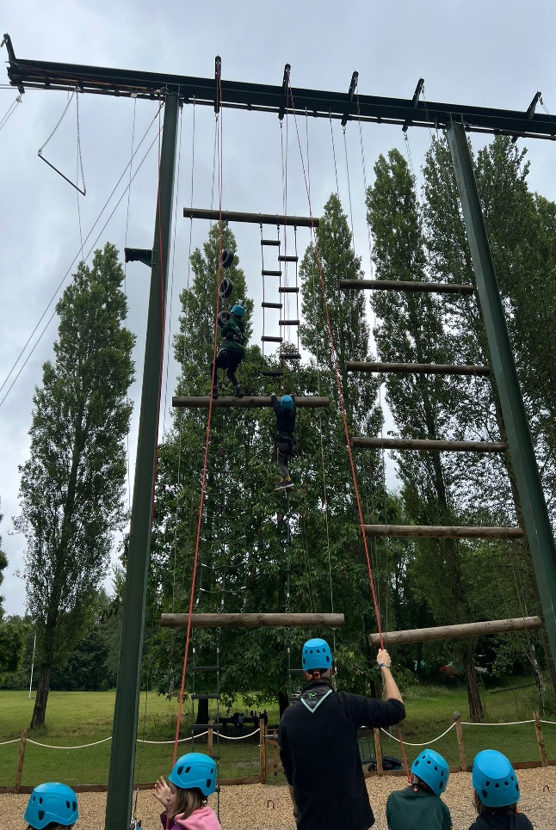

# District Events

**scouts.org.uk/join**

#SkillsForLife

Copyright 2018 The Scout Association Registered Charity numbers 306101/SC038437

[/Eastern Norwich Scout District](https://www.facebook.com/groups/330267707156359)

[@ENorwichScouts](https://x.com/ENorwichScouts)

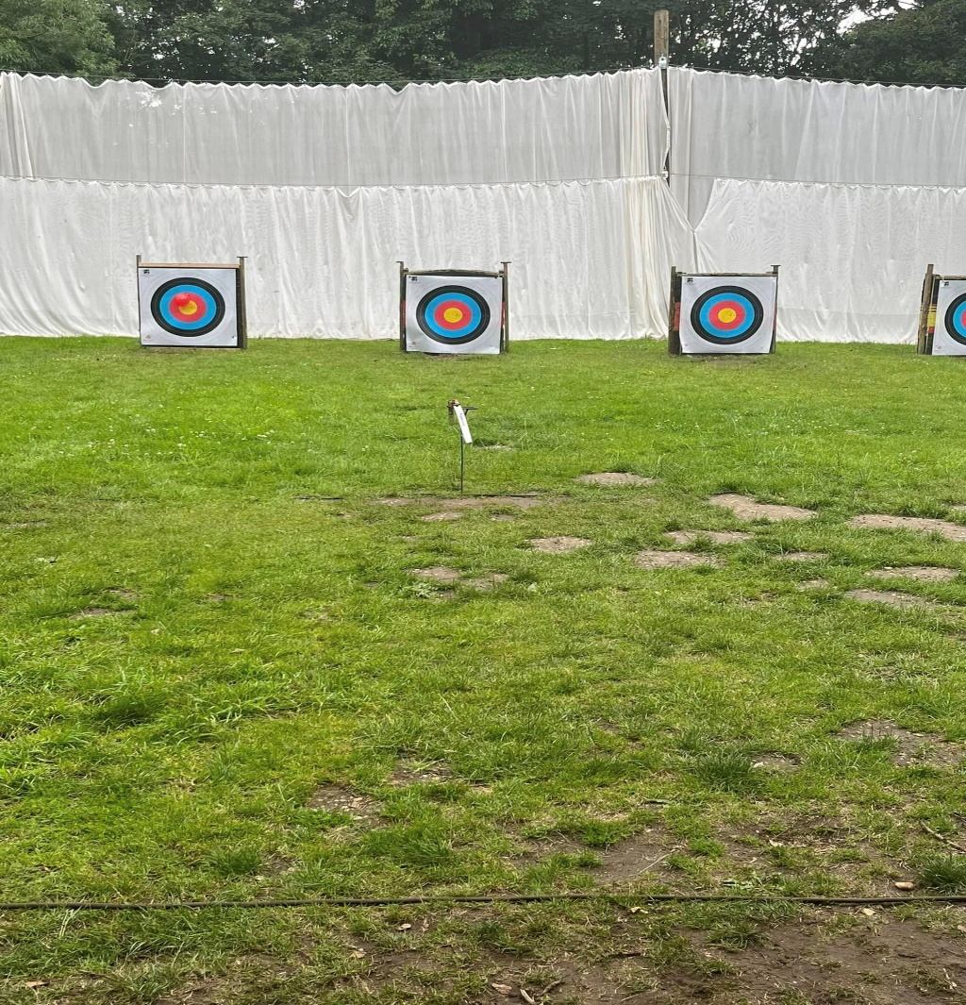

## County Events

1As we approach, going back to school/college, the Beaver colonies and the Cub packs, will be looking forward to their days at BeWilderwood and Pleasurewood Hills, and the Explorers are looking forward to 24hrs of constant activities at Norfolk24, the Scouts will be preparing for the County shooting competition, those who won the district shooting competition, will represent the district. A massive THANK YOU to Grey (Simon Alexander) and Badger (Colin Goff) for their efforts.

Young leader training in Eastern Norwich, is provided by a small team, which is made up of:

District Lead Volunteer (formerly District Commissioner) – Gwen Wilkin

Team Member- Paula Humphrey

Youth Lead Volunteers – Joseph Pocock and Charlie Dunham

Team Member – Suzanne Childs, and we would love to welcome more members to the team.

As part of the young leader training programme each year we host 4 sessions of Module A (which age equivalent training in Safety and safeguarding), all young leaders, even those completing Duke of Edinburgh, need to complete this module within 3 months of starting to help in a younger section. This is supplemented by two multi-module weekends, held at various Scout HQs, where we cover the other modules, if our young leaders attend both multi-module weekends in a year, they will have completed the main modules, except for first aid, withing

## Young Leader Training

The 17th Norwich Scout Group are based at St George’s Church Hall, on Sprowston Road, Norwich.

The group is currently made up of Beavers, who meet on a Wednesday evening, with Cubs following on, Scouts on Fridays, and finally Wildcats Explorer Unit, who meet on Tuesday evening.

Although the group are currently not meeting due to the school holidays, the young people have enjoyed the following activities:.

## Focus on 17th Norwich (RC) Scout Group

Which is covered in a day. With the modules complete, it’s on to the 4 missions, which they do within the section they’re working with, It’s not a lot of writing, but they help plan programmes, lead games/activities, and they learn to work as team, lead a team, all great life skills.

It's not all work though, at each multi module weekend, they can take part in an activity, some of which have included, Crossbows, Tomahawk throwing, the cave bus at Eaton Vale Scout and Guide activity centre and Archery, at the next multi-module weekend we are completing the climbing challenge at Eaton Vale.

Since the team started YL training, have helped many Young leaders achieve their YL belt, to date 23 Young leaders have achieved this award, including our Youth Lead Volunteers, and each time we run the training we all learn something new, including the older members of the team.

